**TI BYTE Simulation Exercise**

**Bonus Simulation Questions**

* **Question 1:**

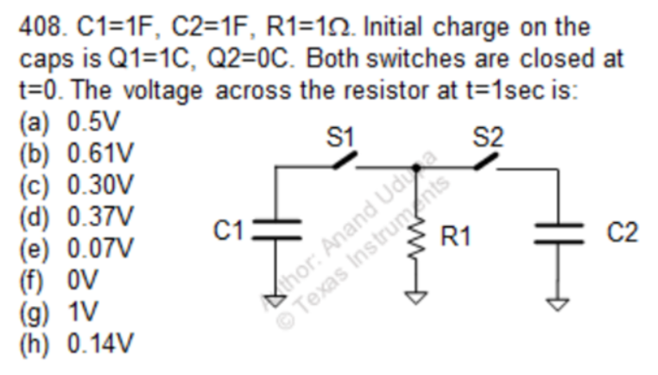

* **QUCS Circuit:**

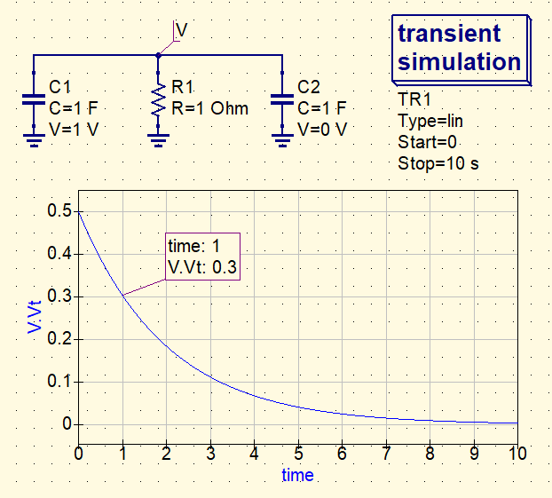

* V is used to label the node and find the voltage at that node.
* Both the capacitors are of 1F. Capacitor C2 is initially uncharged while C1 has an initial charge of 1C.
* At t = 0, since both the switches are closed, they are replaced with short-circuits.
* **QUCS Result:**

Therefore, from the simulation, we get our answer as:

At t = 1s, V = 0.30 V

Answer: (c)

* **Conclusion:**
* In the circuit, at t = 0 when the switches are closed, the capacitors share their charges. So, the common voltage of the two capacitors becomes,
$$V= \frac{C_{1}V_{1}+ C_{2}V_{2}}{C_{1}+ C_{2}}= \frac{1×1+1×0}{1+1}= 0.5 V$$

* Therefore, Vi = 0.5 V
* Now, after ample amount of time, the capacitors discharge through the resistor R1 and thus Vf = 0 V
* For the given circuit, Req = 1 Ω and Ceq = 2 F.
* Therefore, the voltage eqn. of the can be written as:

$$V\left(t\right)=V_{f}+(V_{i}-V_{f})e^{{-t}/τ}$$

where $V_{f}$ is the final voltage, $V_{i}$ is the initial voltage and $τ$ is the time constant = RC = 2 s.

* Therefore, at t = 1 s,

V(t) = [0+(0.5-0) $e^{\frac{-1}{2}}$]

= 0.5 $e^{-0.5}$ = 0.303 V ≈ 0.30 V

* The simulation result almost matches with our calculations.
* **Question 2:**

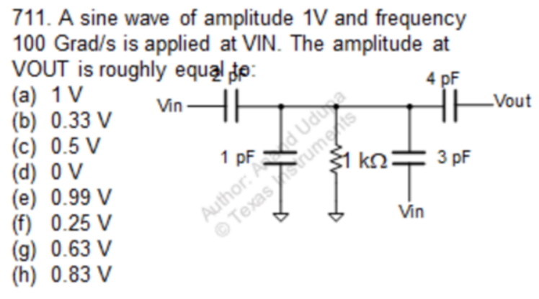

* + **QUCS Circuit:**

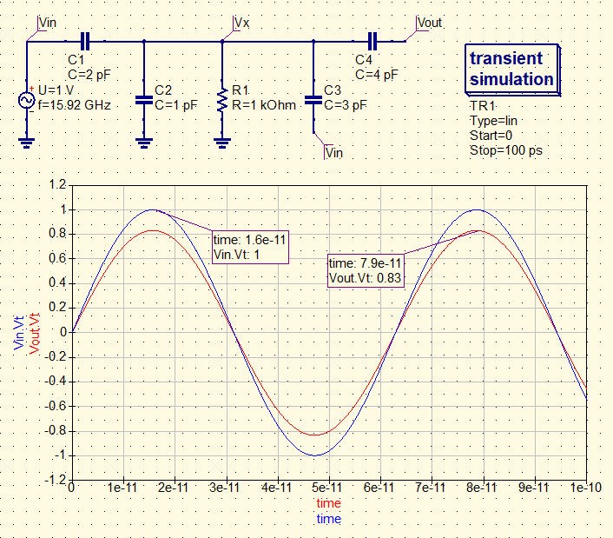

* Vin is a sinusoidal input given to the circuit with an amplitude of 1V and frequency of 100 Grad/s = 15.915 GHz
* Vout is used to label the output node and find the voltage at that node.
* All the capacitors are uncharged.
* **QUCS Result:**

Therefore, from the simulation, we get our answer as:

Amplitude of Vout = 0.83 V

Answer: (h)

* **Conclusion:**
* Given that the frequency of the input signal(ω) is 100 Grad/s,
$$f= \frac{ω}{2π}=15.92 GHz$$

* At this frequency, the 4 pF capacitor essentially acts as a short-circuit, so Vout = Vx.
* Now, the 2 pF and the 3 pF capacitors are then essentially in parallel between Vin and Vx. (C’ = 2 pF + 3 pF = 5 pF)
* So, Vx is thus the voltage division between the 1 pF capacitor and the 5 pF capacitor.
* So, $V_{out}= V_{x}= \frac{5 pF}{1 pF+5 pF}× V_{in}= 5/6V=0.8333 V ≈0.83 V$
* The simulation result almost matches with our calculations.
* **Question 3:**

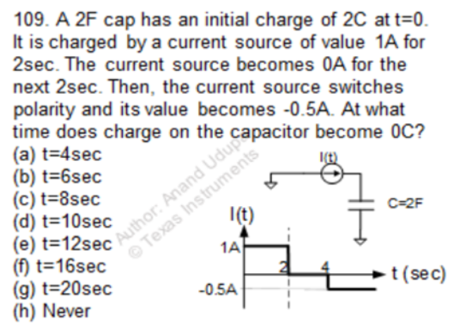

* + **QUCS Circuit:**

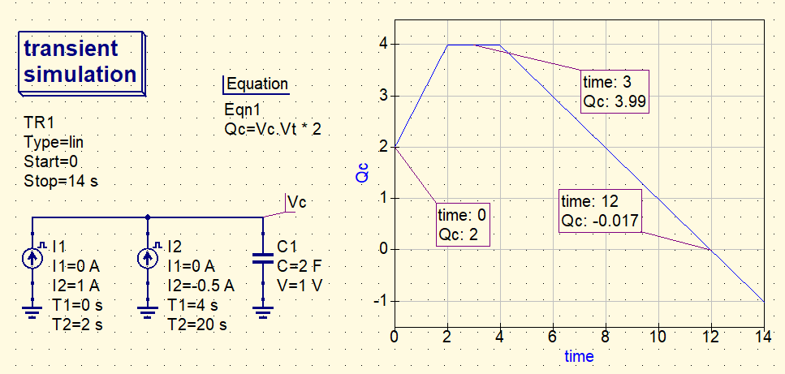

* Vc is used to label the node and find the voltage at that node.
* The capacitor has an initial charge of 2C.
* The two current DC sources are used to implement the given current waveform. They are thus used to charge and discharge the capacitor.
* **QUCS Result:**

Therefore, from the simulation, we get our answer as:

At time t = 12 sec, the charge on the capacitor become 0C.

Answer: (e)

* **Conclusion:**
* The capacitor has an initial charge of 2C.
* For 2 sec, it is charged using a 1A current source. Thus, the total charge delivered to the capacitor = 1A × 2 s = 2C.
* So, the final charge on the capacitor after t = 2 sec, Qc = 2C + 2C = 4C
* Since the current from t = 2 sec to t = 4 sec is zero, no further charge is delivered to the capacitor and it remains the same.
* After t = 4 sec, the current becomes -0.5 A. Thus, the capacitor begins to discharge.
* The total time required by the capacitor to discharge with the -0.5A current source is,
$$∆t= \frac{Q_{c}}{I}= \frac{4 C}{0.5 A}=8 s$$

* So, the final time when the capacitor charge becomes 0 is,
$$T=t+ ∆t=4 s+8 s=12 s$$

* The simulation result almost matches with our calculations.